

CONTROLLED SUBSTANCES

INSTALLATION GUIDE

Version 3.0

March 1997

Department of Veterans Affairs
Software Service
Clinical Ancillary Product Line

Preface

This guide explains how to install Version 3.0 of the Controlled Substances (CS) module of the Pharmacy package.

This package was exported using the Kernel Installation and Distribution
System (KIDS) instead of the VA FileMan DIFROM utility. You will use KIDS to install the software. Please read your KIDS documentation located in Part 5 of your Kernel V. 8.0 Systems Manual and familiarize yourself with KIDS before you install this software.

If your Pharmacy Service intends to use the Health Level Seven (HL7) interface to narcotic dispensing equipment systems, it would be a good idea to familiarize yourself with the HL7 V. 1.6 User manual.

Table of Contents

Intranet
Package Requirements
Steps for Installation
Assigning CS Menus
Allocating Security Keys
Resource Requirements
Hardware Requirements
Disk Space
Journaling Globals and Mapping Routines
Nightly Background Job
Appendix A
Port Set up for HL7 Interface to Narcotic Dispensing Equipment
Appendix B
Starting the HL7 Interface to Narcotic Dispensing Equipment

Intranet

We are now on the intranet, come visit us. (http://www.vista.med.va.gov/softserv/clin_bro.ad/index.html) This address will take you to the Clinical Products page where you will find a listing of all the clinical software manuals and other software manuals. Click on the Controlled Substances (CS) link and it will take you to the CS Homepage. You can also get there by going straight to
http://www.vista.med.va.gov/softserv/clin_nar.row/pharmcs/index.html. (don’t forget to bookmark it!)

In addition, both of these homepages have a Software Service Homepage link. Simply click on this link and then follow the links to the manuals you would like to see.

Package Requirements

The CS module relies on, at least, the following external packages to run effectively:

Package Minimum version needed

4 Kernel 8.0
VA FileMan 21.0
MailMan 7.1
Nursing 2.5
l Outpatient Pharmacy 6.0
6 Auto Replenishment/Ward Stock 2.2
Inpatient Medications 4.0
Drug Accountability 2.0
Integrated Billing 2.0
p Health Level 7 (HL7) 1.6

To run this module, the New Person (#200), Ward Location (#42), Drug (#50), PHARMACY SYSTEM (#59.7), INPATIENT SITE (#59.4), and Prescription (#52) files are needed. The system does not need to be taken down, but the CS and Drug Accountability menus must be made unavailable to the users. This is now handled within the KIDS install process.

4 Patches XU*8.0*26 and XU*8.0*44 must be installed to support the witness identification for Nurse dispensing functionality and the HL7 interface.

l Patch PSO*6*134 should be installed to ensure compatibility between Outpatient Version 6.0 and Controlled Substances Version 3.0.

6 Please note that patch PSGW* 2.2*2 should be installed to ensure compatibility between AR/WS Version 2.2 and Controlled Substances Version 3.0.

p This package is required to support the Health Level 7 (HL7) Interface to Narcotic dispensing Equipment Systems.

Steps for Installation

It is recommended that the following eight steps be performed in a test UCI prior to installing in a production environment.

(1) If your Pharmacy Service intends to use the Health Level 7 (HL7) Interface to
the Narcotic dispensing Equipment Systems (NDES), we strongly suggest that you read through Appendix A of this document and complete your port set up before proceeding with the installation.

(2) Set up Variables. Set up your DUZ and set DUZ(0) to "@" using the ^XUP
entry point.

>D ^XUP <RET> (To set DUZ when responding to the Access Code prompt.
Press return at the OPTION prompt.)

Setting up programmer environment
Terminal Type set to: C-VT100

Select OPTION NAME: KERNEL INSTALLATION & DISTRIBUTION SYSTEM

Select Kernel Installation & Distribution System Option: INstallation

Select Installation Option: LOAd a Distribution
Enter a Host File: CSUB3_0.KID

KIDS Distribution saved on Aug 22, 1996@16:34:54
Comment: CONTROLLED SUBSTANCES VERSION 3.0

This Distribution contains Transport Globals for the following Package(s):
CONTROLLED SUBSTANCES 3.0

Want to Continue with Load? YES//<RET>
Loading Distribution...

Want to RUN the Environment Check Routine? YES//<RET>
Will first run the Environment Check Routine, PSDINPRE

Use CONTROLLED SUBSTANCES 3.0 to install this Distribution.

Note: At this point, you may wish to run the Verify Checksum in Transport Global option. If any of the routine checksums failed, you should contact your distributing IRM Field Office and not proceed with the installation process.
Select Installation Option: INSTall Package(s)

Select INSTALL NAME: CONTROLLED SUBSTANCES 3.0

This Distribution was loaded on Aug 26, 1996@16:12:07 with header of
CONTROLLED SUBSTANCES VERSION 3.0 ;Created on Aug 22, 1996@16:34:5
It consisted of the following Install(s):
CONTROLLED SUBSTANCES 3.0

Will first run the Environment Check Routine, PSDINPRE

Install Questions for CONTROLLED SUBSTANCES 3.0

50 DRUG (Partial Definition)
Note: You already have the 'DRUG' File.

58.2 AOU INVENTORY GROUP (Partial Definition)
Note: You already have the 'AOU INVENTORY GROUP' File.

58.8 DRUG ACCOUNTABILITY STATS
Note: You already have the 'DRUG ACCOUNTABILITY STATS' File.

58.81 DRUG ACCOUNTABILITY TRANSACTION
Note: You already have the 'DRUG ACCOUNTABILITY TRANSACTION' File.

58.82 CS ORDER STATUS (including data)
Note: You already have the 'CS ORDER STATUS' File.
I will MERGE your data with mine.

58.83 CS COMPLETION STATUS (including data)
Note: You already have the 'CS COMPLETION STATUS' File.
I will MERGE your data with mine.

58.84 DRUG ACCOUNTABILITY TRANSACTION TYPE (including data)
Note: You already have the 'DRUG ACCOUNTABILITY TRANSACTION TYPE' File.
I will OVERWRITE your data with mine.

58.85 CS WORKSHEET
Note: You already have the 'CS WORKSHEET' File.

58.86 CS DESTRUCTION
Note: You already have the 'CS DESTRUCTION' File.

58.87 CS CORRECTION LOG
Note: You already have the 'CS CORRECTION LOG' File.

58.88 CS IRL PROGRAM (including data)
Note: You already have the 'CS IRL PROGRAM' File.
I will OVERWRITE your data with mine.

58.89 CS ERROR LOG
Note: You already have the 'CS ERROR LOG' File.

59.4 INPATIENT SITE (Partial Definition)
Note: You already have the 'INPATIENT SITE' File.

59.7 PHARMACY SYSTEM (Partial Definition)
Note: You already have the 'PHARMACY SYSTEM' File.

Do you want to enter/edit your interface setup
for Narcotic Dispensing Equipment Systems? No// ?

Interface to Narcotic Dispensing Equipment Systems

Version 3.0 of the Controlled Substances package uses the HL7 package
to provide a generic interface to Narcotic Dispensing Equipment Systems
(NDES). HL7 or Health Level Seven is a standard protocol which specifies
the implementation of interfaces between two computer applications (sender
and receiver) from different vendors for electronic data exchange in
health care environments. If your Pharmacy sService is using an NDES such
as Access, Meditrol, Pyxis, or Suremed you may wish to set up the
interface. This will be accomplished by adding entries to the HL7
APPLICATION PARAMETER (#771), HL LOWER LEVEL PROTOCOL PARAMETER (#869.2),
and HL LOGICAL LINK (#870) files. You will be asked to identify an HL7
device which must exist as entry in your DEVICE file (#3.5).

The PSDHLK routine is invoked by the Controlled Substances post-init.
The routine, PSDHL7 is also independently invokable at any time that a site
needs to set up their interface for nNarcotic dDispensing eEquipment sSystems.

If you do NOT want to perform this step at the time of the post-init,
you can simply D ^PSDHL7 when you're ready.

Select HELP SYSTEM action or <return>:<RET>

Do you want to enter edit your interface setup
for narcotic dispensing equipment systems? No//Yes Only answer "yes" if you intend to use the HL7 interface to a narcotic dispensing equipment system.

Select one of the following:

H Hybrid Lower Layer Protocol {Pyxis, Suremed, Meditrol}
X X3.28 Protocol

Select a communications protocol: H//<RET> ybrid Lower Layer Protocol
HLLP DEVICE: [Enter your Interface device from your DEVICE file here.]

Want to DISABLE Scheduled Options and Options? YES//<RET>

Enter options you wish to mark as 'Out Of Order': PSA*

{Because Drug Accountability shares many files with Controlled Substances, the PSA* options should also be placed Out Of Order.}

{If you have any local options that might be affected by this install, it is recommended that you mark them Out of Order.}

Enter options you wish to mark as 'Out Of Order': ??

Out of Order Manager

You are building a list of options and/or protocols to be marked 'Out
Of Order'. You may enter them in several different ways:

You may simply enter an option or protocol name,
or NAM* to specify all that begin with the characters 'NAM'
or NAM1-NAM2 to specify all the options or protocols that fall
alphabetically between NAM1 and NAM2 inclusive,
or * to select all options or protocols,
or - with any of the above to remove items already selected,
or ^ to quit and exit the program,
or ^PR to switch from working with options to protocols,
or ^OP to switch from working with protocols to options,
or ? to see a brief help prompt,
or ?? to see this help screen again,
or ??? to see the list of items chosen so far,
or ???? to see the Option or Protocol File,

Select HELP SYSTEM action or <return>:<RET>

Enter options you wish to mark as 'Out Of Order': ???

{To see a list of items chosen so far, enter ???.}

You will place Out Of Order the following options:<RET>

{What follows is a partial list, but the install automatically places all Controlled Substances options and protocols out of order.}

Set Up CS (Build Files) Menu [PSD SETUP] (IEN = 4306)
Enter/Edit CS Drug Location Codes [PSD DRUG LOC EDIT] (IEN = 4307)
Create/Edit the Narcotic Area of Use [PSD NAOU EDIT] (IEN = 4308)

You will place Out Of Order the following protocols:<RET>

[PSD PAT ADT] (IEN = 937)
[PSD MM] (IEN = 938)
Controlled Substances admit (A01) server [PSD A01 SERVER] (IEN = 939)
Controlled Substances admit client [PSD A01 CLIENT] (IEN = 940)
Controlled Substances transfer (A02) server [PSD A02 SERVER] (IEN = 941)
Controlled Substances transfer (A02) client [PSD A02 CLIENT] (IEN = 942)
Controlled Substances discharge (A03) server [PSD A03 SERVER] (IEN = 943)
Controlled Substances discharge (A03) client [PSD A03 CLIENT] (IEN = 944)

Enter options you wish to mark as 'Out Of Order':<RET>

Enter protocols you wish to mark as 'Out Of Order':<RET>

Enter protocols you wish to mark as 'Out Of Order':<RET>

Delay Install (Minutes): (0-60): 0//<RET>

Enter the Device you want to print the Install messages.
You can queue the install by enter a 'Q' at the device prompt.
Enter a '^' to abort the install.

DEVICE: HOME// [Select Print Device]

Install Started for CONTROLLED SUBSTANCES 3.0 :
Aug 26, 1996@16:13:57

Installing Routines:
Aug 26, 1996@16:14:21

Installing Data Dictionaries:
Aug 26, 1996@16:14:41
Installing Data:
Aug 26, 1996@16:14:42

Installing PACKAGE COMPONENTS:

Installing HELP FRAME

Installing SECURITY KEY

Installing INPUT TEMPLATE

Installing HL LOWER LEVEL PROTOCOL PARAMETER

Installing HL LOGICAL LINK

Installing HL7 APPLICATION PARAMETER

Installing PROTOCOL

Located in the PSD (CONTROLLED SUBSTANCES) namespace.
Located in the PSD (CONTROLLED SUBSTANCES) namespace.
Located in the PSD (CONTROLLED SUBSTANCES) namespace.
Located in the PSD (CONTROLLED SUBSTANCES) namespace.
Located in the PSD (CONTROLLED SUBSTANCES) namespace.
Located in the PSD (CONTROLLED SUBSTANCES) namespace.
Located in the PSD (CONTROLLED SUBSTANCES) namespace.

Installing LIST TEMPLATE
Aug 26, 1996@16:15:27

Installing OPTION

Running Post-Install Routine: ^PSDIPOST

CONTROLLED SUBSTANCES VERSION 2.0 has been previously installed,
no post-init conversion required.
Finished.

{You will only see the next two updates if you answered yes to the interface setup question.}

Updating FACILITY NAME for PSD-CS entry in file #771.
Updating DEVICE for PSD-NDES HLLP entry in file #869.2.

Updating Routine file...

Updating KIDS files...

CONTROLLED SUBSTANCES 3.0 Installed.
Aug 26, 1996@16:15:50..

Install Message sent #71

Install Completed

Select Installation Option:

Use the KIDS Build File Print option if you wish to obtain a complete listing of the package components (e.g., routines and options) sent with this Distribution file.

Use the KIDS Install File Print option if you wish to print out the results of the installation process.
After you have installed the package in a test account, and pharmacy has familiarized themselves with all the options, you should repeat this procedure in a live account.

(3)Æ Set up hardware devices required by Version 3.0. This is an important step. Version 2.0 of Controlled Substances printed green sheets on pre-printed forms using either an HP III or Kyocera printer. Version 3.0 prints these same forms on plain paper but requires updates to your TERMINAL TYPE file in order to format these forms correctly. The routine PSDTER is provided for your convenience to perform these updates. It must be run on the TERMINAL TYPE entry that is attached to the DEVICE that Pharmacy currently uses for printing green sheets or Pharmacy will be unable to continue to print greens sheets. This is a critical step in the dispensing of controlled substances. For an example of running the routine, please see page 26.

(4) The install process takes approximately 20 minutes to run. File security codes of the Ò@Ó have been exported. A post-init routine will only run if Controlled Substances Version 2.0 has not been installed. It will mark entries in your Drug file (#50) for CS use based on the Drug Enforcement Agency (DEA) Special Handling Data. The re-indexing of data in the APPLICATION PACKAGESÕ USE field (#63) in the DRUG file (#50), DATE/TIME TURN IN DESTROY field (#37), and the RECEIPT DATE/TIME field (#21) in the DRUG ACCOUNTABILITY TRANSACTION file (#58.81), and the DATE/TIME DESTROYED field (#10) in the CS DESTRUCTION file (#58.86), also occurs during the post-init process. The security keys PSDMGR, PSD PARAM, PSD TRAN, PSD ERROR, and PSD NURSE will be created, if necessary.

(5) Assign the appropriate menus to CS users.

(6) Allocate necessary security keys to CS users.

(7) Enable nightly background job. See instructions on page 40.

(8) If your Pharmacy Service intends to use the Health Level 7 (HL7) Interface to
the Narcotic dispensing Equipment Systems, please read Appendix B of this document for instructions on starting the interface.

Assigning CS Menus

The following menus are available for Pharmacy personnel:

Controlled Substances Menu...[PSD MENU]

Supervisor (CS) Menu...[PSD MGR]
**>Locked with PSDMGR
Technician (CS Pharmacy) Menu...[PSD PHARM TECH]
Pharmacist Menu...[PSD TRANSACTION MENU]
Production Reports...[PSD PRODUCTION REPORTS]
Barcode Drug Labels for Vault [PSD LABEL VAULT]

All nursing personnel, using the CS software, may be assigned the PSD NURSE MENU as a menu option. Nursing Supervisors may want access to the PSD NURSE SUPR MENU. Controlled Substances inspectors may be assigned the PSD INSPECTOR MENU. Some stations design their own menus for individual users. If this is the case, then only the top level CS menus should contain the following entry and exit code in the OPTION file (#19) to ensure that users are prompted only once for an Inpatient Site:

ENTRY ACTION : I '$D(PSDSITE) D ^PSDSET
EXIT ACTION: K PSDSITE

This entry and exit code must be present because the PSDSITE variable is set as users enter the package. If the KernelÕs Ò^ OPTION NAMEÓ feature is used to jump directly into lower levels of the CS package, then the Inpatient Site Name prompt must be answered in order to define the PSDSITE variable. All options are independently secured; however, if the instructions above are not followed, users will be repeatedly asked to select an Inpatient Site if there are two or more sites that are flagged as selectable for CS use.

Allocating Security Keys

There are nine keys associated with CS:

¥ PSD ERROR Allocate this key to pharmacy supervisors responsible for maintaining the narcotic vault.

This key controls access to reports listing various errors and exception conditions generated when entries are filed from the barcode TRAKKER. Also, the holders of this key will receive electronic mail messages created by using the TRAKKER.

¥ PSDMGR Allocate this key to the Inpatient Pharmacy Coordinators. This key controls the editing of CS files for package set up and it locks the Supervisor (CS) Menu .

¥ PSD NURSE Allocate this key to nurses, usually LPNs, who may only receive and administer controlled substances drugs, but cannot place order requests.

¥ PSD PARAM Allocate this key to only the Inpatient Pharmacy Coordinators. This key controls the printing of the Green Sheets and the range of automated dispensing numbers for a dispensing site.

¥ PSD TRAN Allocate this key only to the Inpatient Pharmacy Coordinator. This key controls the access to the Transfer Stock Entries option. Users can copy stock entries from one Narcotic Area Of Use (NAOU) into another NAOU or from an Auto Replenishment/Ward Stock (AR/WS) Area Of Use (AOU) into an NAOU.

¥ PSJ PHARM TECH Allocate this key to pharmacy technicians handling controlled substances orders.

¥ PSJ RNURSE Allocate this key to nurses who request and receive controlled substances orders on the wards.

¥ PSJ RPHARM Allocate this key to pharmacists who can dispense and receive controlled substances drugs.

¥ PSD TECH This key will give access to the List On-Hand Amounts, Transfer Drugs between Dispensing Sites Report, and the Daily Activity Log options on the Pharmacy Technician Menu.

Resource Requirements

Hardware Requirements

The following equipment is recommended to successfully implement Version 3.0:

Intermec TRAKKER 9440 (Barcode Reader)
HP LaserJet III (or any compatible laser printer)
VT320 (bi-directional only) or any bi-directional flow CRT

The laser single sheet feed printer is required to print the pre-printed VA FORM
10-2638 and barcode ID labels. It is recommended that the printer be physically located in the narcotic vault for efficiency and security.

The laser printer must be a selectable device via the terminal server. Barcode printing is not available with a slaved printer.

The barcode TRAKKERs and CRTs are required to download/upload data necessary in maintaining a perpetual inventory within the pharmacy narcotic vault.

To support barcode label printing and downloading/uploading via the TRAKKER, certain hardware specific parameters for the TERMINAL TYPE file (#3.2) and DEVICE file (#3.5) are necessary. To assist Information Resources Management (IRM) in setting up these devices the routine PSDTER has been included in the routine set. The TERMINAL TYPE file (#3.2) information includes right margin, form feed, page length, back space, open execute, barcode on, and barcode off. The DEVICE file (#3.5) data includes margin width, form feed, page length, back space, and subtype. For the TRAKKER, open printer port and close printer port are included in the TERMINAL TYPE file (#3.2) information. See page 32 for examples in setting up the devices using the routine PSDTER.
Kyocera Setup for Printing Barcodes

DEVICE file (#3.5):

NAME: KYOCERA BARCODER $I: <$I value>
ASK DEVICE: YES ASK PARAMETERS: YES
SIGN-ON/SYSTEM DEVICE: NO LOCATION OF TERMINAL: <location>
MARGIN WIDTH: 0 FORM FEED: #
PAGE LENGTH: 66 BACK SPACE: $C(8)
SUBTYPE: P-KYOCERA-BARCODE TYPE: TERMINAL

TERMINAL TYPE file (#3.2):

NAME: P-KYOCERA-BARCODE SELECTABLE AT SIGN-ON: NO
RIGHT MARGIN: 0 FORM FEED: #
PAGE LENGTH: 66 BACK SPACE: $C(8)
OPEN EXECUTE: W "!R! RES;FONT "_$S($G(PSDCPI)=10:1,1:6)_";EXIT;"
10 PITCH: "!R! FONT1; EXIT;" 12 PITCH: "!R! FONT6; EXIT;"
DEFAULT LINES PER INCH: "!R! SLM 2; EXIT;"
X LINES PER INCH: "!R! SLPI 4.1; EXIT;"
BAR CODE OFF: "', 60, 60, 3, 6, 6, 6, 3, 6, 6, 6;"_$S('$D(PSDX1):"",PSDX1=PSDC
NT:"MRP 0 , 60;",1:"")_"EXIT;"
BAR CODE ON: "!R! FONT 6; UNIT D; "_$S('$D(PSDX1):"",PSDX1=1:"MRP 0,-60 ; ",1:"")_$S('$D(PSDX1):"",1:"MRP "_(PSDX1>1*810+38)_" , 0 ;")_" BARC 19, N, '"

HP LaserJet III Setup for Printing Barcodes

The barcode font cartridge must be installed prior to trying to print any barcode labels. Refer to page 11 in the Using the Hewlett-Packard Barcodes and More Font Cartridges guide.

DEVICE file (#3.5):

NAME: HP III BARCODER $I: <$I value>
ASK DEVICE: YES ASK PARAMETERS: YES
SIGN-ON/SYSTEM DEVICE: NO LOCATION OF TERMINAL: <location>
MARGIN WIDTH: 0 FORM FEED: #
PAGE LENGTH: 58 BACK SPACE: $C(8)
SUBTYPE: P-HP BARCODER TYPE: TERMINAL
LAT SERVER NODE: <node name> LAT SERVER PORT: <port number>
VMS DEVICE TYPE: NOT SPOOLED LAT PORT SPEED: 96
TERMINAL TYPE file (#3.2):

NAME: P-HP BARCODER SELECTABLE AT SIGN-ON: NO
RIGHT MARGIN: 0 FORM FEED: #
PAGE LENGTH: 58 BACK SPACE: $C(8)
OPEN EXECUTE: W
$C(27)_"E"_$C(27)_"&l0O"_$C(27)_"(8U"_$C(27)_"(s0p"_$S($G(PSDC
PI)=10:"10h14",1:"12h12")_"v0s0b6T"
10 PITCH: $C(27)_"(s10H" 12 PITCH: $C(27)_"(s12H"
HIGH INTENSITY (BOLD): $C(27)_"(s4b"
DEFAULT LINES PER INCH: $C(27)_"&l8C"
X LINES PER INCH: $C(27)_"&l12C"
BAR CODE OFF:
"*"_$C(27)_"&l0O"_$C(27)_"(8U"_$C(27)_"(s0p"_$S($G(PSDCPI)=10:"1
0h14",1:"12h12")_"v0s0b6T"
BAR CODE ON: $S($D(PSDX2):$C(27)_"*p"_(PSDX2-1*300+200)_"y*p"_(PSDX1-
1*810+38)_"X",1:"")_$C(27)_"(0Y"_$C(27)_"(s0p8.1h12v0s0b0T*"
Preparation of Portable Barcode Reader (TRAKKER 9440)

Controlled Substances Version 3.0 includes options for downloading Interactive Reader Language (IRL) programs to the TRAKKER. For these options to function, the TRAKKER must be connected to your VISTA (Veterans Health Information Systems and Technology Architecture) computer system. The TRAKKER comes with an RS-232 cable. The end of the cable that is intended to be connected to your system terminates to a DBÑ25 PIN connector.

The TRAKKER may be connected to your system via the auxiliary port of any CRT that supports complete bi-directional data flow and flow control (XON-XOFF) through the auxiliary port. Whatever strategy works for addressing a slaved printer to the CRT will also work for the TRAKKER.

Preparing the TRAKKER for Operation

The following procedure illustrates stepping through the configuration process to verify whether the TRAKKER is properly prepared to interface with VISTA.

 Note: A brief example of the TRAKKER setup may be displayed by running routine PSDTRAK from programmer mode.

To enter the configuration mode you must do the following:

1. Turn the TRAKKER on by pressing the [on-off] key. The unit should
perform a brief self-test and then display a Ready prompt.

2. Hold down the [ctrl] key and press E. The words ÒCONFIGURATION
MENU:Ó should appear on the first line of the TRAKKER display screen. You are now in the configuration mode.

To prepare the TRAKKER for operation with the Veterans Health Information Systems and Technology Architecture (VISTA):

3. Press the [enter] key until you are prompted to ÒSelect or modify operating parameters?Ó. The word NO will appear on the fourth TRAKKER display line.

4. Change NO to YES by pressing the [space] key.

5. Use the [enter] key to step through the basic operating parameters. Unless otherwise instructed, use the [space] key to make your selections:

a. BEEP VOLUME: Set this according to your preference. If your work environment is noisy, choose HIGH.

b. DISPLAY MODE: This tells the TRAKKER how to display data that you enter. Choose BUFFERED.

c. CHARACTER SET: This selects an alphabet. Choose US-ASCII.

d. CPU RESP REQD MODE: Tells the TRAKKER whether to wait for an acknowledgment from VISTA after each transmission of uploaded data. Choose DISABLED.

e. PREAMBLE A REQUIRED: Tells the TRAKKER whether to check for one specific preamble on all data entered. Choose NO.

f. LASER SCANNER MODE: Tells the TRAKKER whether to allow continuous scanning of barcode labels without release of the laser trigger in between. Choose ONE-SHOT TRIGGER.

g. APPEND TIME TO DATA: Instructs the TRAKKER to add the correct time to each data record as it is transmitted. Choose NO.

h. TIME IN SECONDS: Tells the TRAKKER whether time displays should include seconds. Choose YES.

i. RESUME IRL PROGRAM: Choose NO.

j. AUTOMATIC SHUTÑOFF: A time-out feature such that the TRAKKER will turn itself off after a specified period of inactivity in order to conserve battery power. You must enter your selection (in minutes) as a number. The TRAKKER will ignore the [space] key. We suggest a 10 minute time-out period.

k. BACKLIGHT TIMEOUT: A time-out feature on backlighting of the TRAKKER display screen intended to conserve battery power. Selections are made in seconds. We suggest a 60 second time-out period.

6. The next configuration heading is ÒSelect or modify comm protocol?Ó Use the [space] key to select POINT TO POINT.
7. Use the [enter] key to step through the comm protocol:

a. CHECK CTS: Tells the TRAKKER whether or not to look for a CTS (clear to send) signal before transmitting data. Since VISTA uses XON/XOFF, choose NO.

b. XON: When XON/XOFF protocol is used, the XON character must be specified here. Hold down the [ctrl] key and press Q. DC1 should appear on the last TRAKKER display line. Press [enter] to continue.

c. XOFF: Hold down the [ctrl] key and press S. Observe DC3 and press [enter] to continue.

d. BAUD RATE: The TRAKKER data transmission speed. 1200 baud is recommended.

e. PARITY: Selection is DISABLED.

f DATA BITS: Select 8.

g. STOP BITS: Select 1.

h. TIMEOUT DELAY: Tells the TRAKKER how long to wait for the next character of a downloaded IRL program before declaring an error condition. Choose 10 seconds.

i. INTERCHAR DELAY: Tells the TRAKKER how long to pause between characters when uploading data to VISTA. Choose 50 milliseconds (ms).

j. TURNAROUND DELAY: Delay time between receipt of a character from VISTA and acknowledgment by the TRAKKER. This parameter is not critical with an XON/XOFF protocol. Choose 0 ms.

8. When you have set the TURNAROUND DELAY, you will once again see the ÒSelect or modify barcodes?Ó prompt. The TRAKKER is now configured for use with VISTA.

Press the [alt] key and then the [E] for escape to save any changes that you may have made. Once saved, they will remain in a non-volatile section of TRAKKER memory until the TRAKKER is re-configured.

If you made a mistake and want to exit the configuration mode without saving any changes, hold down the [crtl] key and press [Z]. Do this instead of the escape sequence ([alt], [E]) described above.
 If the TRAKKER has been configured differently, first it must be RESET. For details on this procedure, refer to the INTERMEC 944X TRAKKER READERS UserÕs Manual. Next, you must CONFIGURE the TRAKKER, repeating steps 1-8 on Preparing the TRAKKER for Operation.
Note: The clock should be set on the TRAKKER before users start performing inventories. It is not necessary to press enter after responding yes to setting the clock.

Setting the TRAKKER clock:

After having turned the TRAKKER on, press [Ctrl]-[T].

The following will be displayed:

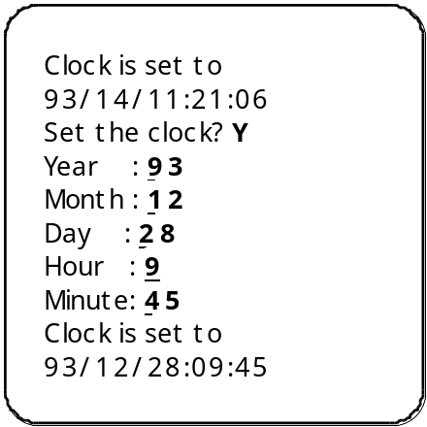

Interfacing

Interfacing the TRAKKER 9440 to a VT-320 auxiliary port

The auxiliary port of the VT-320 is a six pin modular jack, so you will need a cable with a six pin modular plug on one end and a male DB-25 connector on the other.
The Pharmacist Menu is shown in reverse video for clarity.

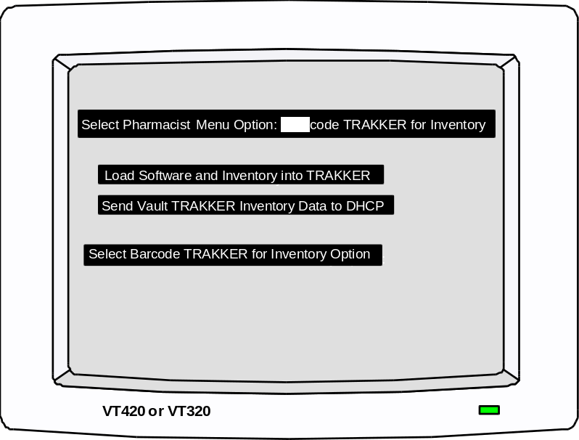  Auxiliary  Port
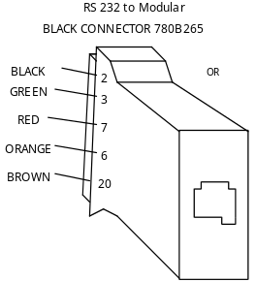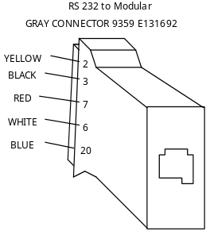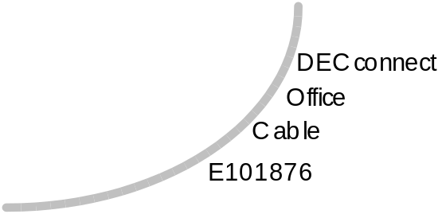
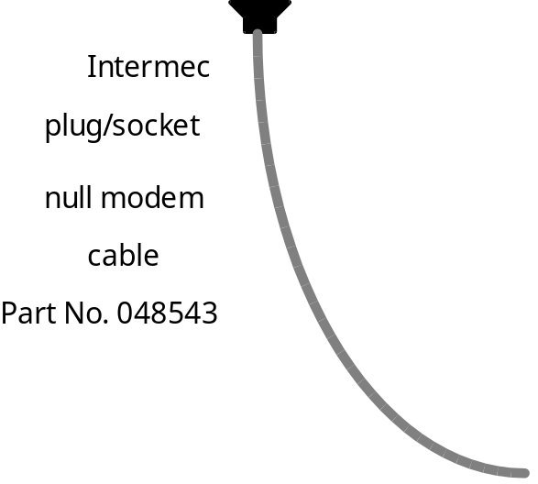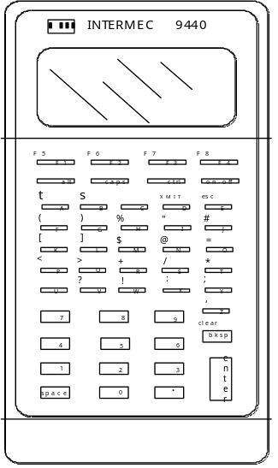

The PRINTER SET UP SCREEN of the VT-320 will allow you to configure the CRT for use with a TRAKKER. To get to this screen:

1. Hold the SHIFT key and press SET UP

2. Use the cursor control keys (right arrow) to move the cursor to the box labeled Printer.

3. Press the ENTER key.

From this point, you can set the software selectable features of the auxiliary port as follows:

1. Speed: The baud rate of the auxiliary port. This must match the baud rate of the TRAKKER. 1200 is commonly used.

2. Printer to Host Communication: This must be set to Printer to Host for
the TRAKKER upload/download operations.

3. Print Mode: Determines how the auxiliary port is controlled. Proper setting is Normal Print Mode.

4. XOFF: This selects whether or not the auxiliary port will use XON/XOFF data flow control. Proper setting is XOFF.

5. Bits and Parity: Selects a character format for the auxiliary port. Must match the character format of the TRAKKER.

6. Stop Bit: Selects the number of stop bits. Must match the format of the TRAKKER. 1 stop bit is commonly used.

7. Print Region: Unimportant for downloading or uploading. Commonly set to Print Full Page.

8. Printed Data Type: Used primarily with slaved printer. Not critical for downloading or uploading. Commonly set to National Only.

9. Print Terminator: Selects whether or not the VT-320 should send a form feed at the end of each print operation. Proper setting is No Terminator.

Finally, you will need appropriate entries in your TERMINAL TYPE file (#3.2) and the DEVICE file (#3.5). For IRM, the routine PSDTER will allow you to setup the TERMINAL TYPE file (#3.2) and DEVICE file (#3.5) information. This routine may be run from programmers mode. Refer to page 30 in the Installation Guide for an example.
The following examples are known to work:

In the TERMINAL TYPE file (#3.2):

NAME : C-VT420 (9440)
FORM FEED : #
OPEN EXECUTE : W $C(0)
DESCRIPTION : TRAKKER 9440 TO AUXILIARY PORT OF VT420
OPEN PRINTER PORT : W $C(27)_"[5i"
CLOSE PRINTER PORT : W $C(27)_"[4i"
RIGHT MARGIN : 80
PAGE LENGTH : 9999

In the DEVICE file (#3.5):

NAME : TRAKKERSL
LOCATION : SLAVED 9440 FROM VT420 AUXILIARY PORT
MARGIN WIDTH : 80
PAGE LENGTH : 9999
MNEMONIC : TRAKKERSL
FORM FEED : #
BACK SPACE : $C(8)
SUB-TYPE : C-VT420 (9440)
TYPE : TERMINAL
$I : 0 (zero)

-------------------------------------------------------------------

Functions on the TRAKKER:

[Ctrl]-[T] This will give you access to set the clock.

[Ctrl]-[enter]-[E] This will give you access to end an IRL session.
Simultaneously press the [Ctrl]-[enter] keys,
release them, then press [E].

[Ctrl]-[enter]-[C] This will give you access to clear the data files.
Simultaneously press the [Ctrl]-[enter] keys,
release them, then press [C].

[To clear the data files you must have already ended the IRL session.]

Example of using PSDTER routine

D ^XUP

Setting up programmer environment
Access code:XXXXX

Terminal Type set to: C-VT100
Select OPTION NAME: <RET>

>D ^PSDTER
Select one of the following:

1 Load all three barcode Terminal Types
2 Load the P-HP BARCODER Terminal Type
3 Load the P-KYOCERA-BARCODE Terminal Type
4 Load the C-VT420 (9440) Terminal Type
5 Select your own Terminal Type
6 Display
7 Nevermind

Enter response: ?

If any of the selected Terminal Types already exist, I will ask for your
approval before proceeding.

Select one of the following:

1 Load all three barcode Terminal Types
2 Load the P-HP BARCODER Terminal Type
3 Load the P-KYOCERA-BARCODE Terminal Type
4 Load the C-VT420 (9440) Terminal Type
5 Select your own Terminal Type
6 Display
7 Nevermind

Enter response: 1 Load all three barcode Terminal Types

Current settings: [If a P-HP BARCODER TERMINAL TYPE already exist, current settings will be displayed.]

Are you sure that you want to stuff the Controlled Substances barcode
set-up into the P-HP BARCODER Terminal Type? No// YES

Updating P-HP BARCODER.

Update the DEVICE file? No// ?

Yes, and I will add the P-HP BARCODER Terminal Type and update a few
fields in the device of your selection.

Update the DEVICE file? No//<RET>

Current settings: [If a P-KYOCERA BARCODE TERMINAL TYPE already exist, current settings will be displayed.]

Are you sure that you want to stuff the Controlled Substances barcode
set-up into the P-KYOCERA-BARCODE Terminal Type? No// ?

Yes and I'll update OPEN EXECUTE, RIGHT MARGIN, PAGE LENGTH, Etc. fields.

Are you sure that you want to stuff the Controlled Substances barcode
set-up into the P-KYOCERA-BARCODE Terminal Type? No// YES

Updating P-KYOCERA-BARCODE.

Update the DEVICE file? No//<RET>

Are you sure that you want to stuff the Controlled Substances barcode
set-up into the C-VT420 (9440) Terminal Type? No// YES

Updating C-VT420 (9440).

Update the DEVICE file? No//<RET>

The HP LaserJet III and the Kyocera laser printer setup used in testing the printing of the VA FORM 10-2638 follows on the next pages.
HP LaserJet III Printer Setup

NAME: P-HP BARCODER SELECTABLE AT SIGN-ON: NO
RIGHT MARGIN: 0 FORM FEED: #
PAGE LENGTH: 58 BACK SPACE: $C(8)
OPEN EXECUTE: W $C(27)_"E"_$C(27)_"&l0O"_$C(27)_"(8U"_$C(27)_"(s0p"_$S($G(PSDC
PI)=10:"10h14",1:"12h12")_"v0s0b6T"
10 PITCH: $C(27)_"(s10H" 12 PITCH: $C(27)_"(s12H"
HIGH INTENSITY (BOLD): $C(27)_"(s4b" DEFAULT LINES PER INCH: $C(27)_"&l8C"
X LINES PER INCH: $C(27)_"&l12C"
BAR CODE OFF: "*"_$C(27)_"&l0O"_$C(27)_"(8U"_$C(27)_"(s0p"_$S($G(PSDCPI)=10:"1
0h14",1:"12h12")_"v0s0b6T"
BAR CODE ON: $S($D(PSDX2):$C(27)_"*p"_(PSDX2-1*300+200)_"y*p"_(PSDX1-1*810+38)
_"X",1:"")_$C(27)_"(0Y"_$C(27)_"(s0p8.1h12v0s0b0T*"

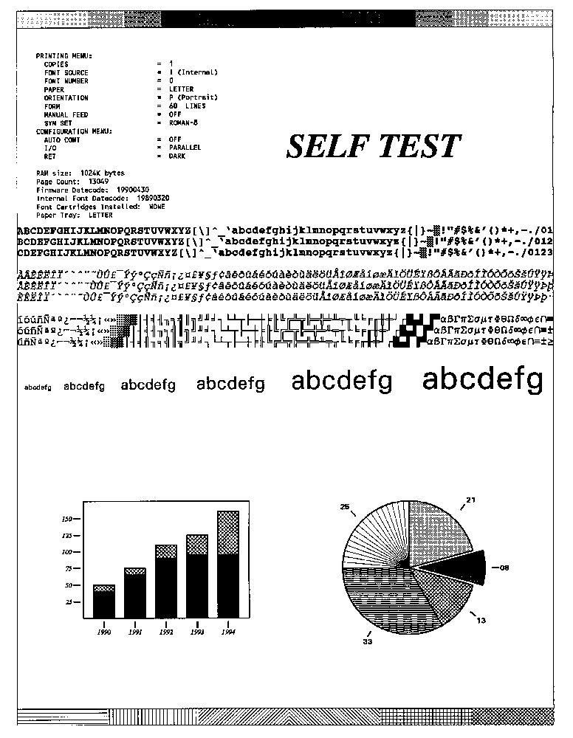
Kyocera Laser Printer Setup

NAME: P-KYOCERA-BARCODE SELECTABLE AT SIGN-ON: NO
RIGHT MARGIN: 0 FORM FEED: #
PAGE LENGTH: 66 BACK SPACE: $C(8)
OPEN EXECUTE: W "!R! RES;FONT "_$S($G(PSDCPI)=10:1,1:6)_";EXIT;"
10 PITCH: "!R! FONT1; EXIT;" 12 PITCH: "!R! FONT6; EXIT;"
DEFAULT LINES PER INCH: "!R! SLM 2; EXIT;"
X LINES PER INCH: "!R! SLPI 4.1; EXIT;"
BAR CODE OFF: "', 60, 60, 3, 6, 6, 6, 3, 6, 6, 6;"_$S('$D(PSDX1):"",PSDX1=PSDC
NT:"MRP 0 , 60;",1:"")_"EXIT;"
BAR CODE ON: "!R! FONT 6; UNIT D; "_$S('$D(PSDX1):"",PSDX1=1:"MRP 0,-60 ; ",1:
"")_$S('$D(PSDX1):"",1:"MRP "_(PSDX1>1*810+38)_" , 0 ;")_" BARC 19, N, '"

LASER PRINTER STATUS PAGE

Software version 6.45 - 20 , released 04/90.
Units : Inches. Page : Portrait.
Current font : 1. Current country : 0.
Copies : 1. Current emulation : 6.

Margins Spacings
Top 0.300 Line 0.167
Bottom 10.300 Character 0.100
Left 0.000 Pen width 0.010
Right 8.000

Memory allocation (Kbytes)
User memory avail. 187.225 In use (System) 108.773
Prescribe MCRO buff. 4.996 In use 0.000
PCL MCRO buff 3.500 In use 0.000
Parallel buff. size 10.000
RS232C buff. size 10.000
Raster size 128.000

Miscellaneous status
Option (Comment) Value Option(Comment) Value
-------------------------------------------------------
CO(Reserved) 0 P1(Default Emulation) 6
C1(Page orientation) 0 P2(C.R. action) 1
C2(Dflt font Num-mid.) 0 P3(L.F. action) 1
C3(Dflt font Num-low) 1 P9(Escape Char.) 82
C4(PCL MCRO buff.) 0 UO(Line/Inch_high) 6
C5(Dflt font Num-High) 0 U1(Line/Inch_low) 0
A1(Top margin_high) 0 U2(Char/Inch_high) 10
A2(Top margin_low) 0 U3(Char/Inch_low) 0
A3(Left margin_high) 0 U5(Status page) 0
A4(Left margin_low) 0 U6(Country code) 0
A5(Page length_high) 13 U7(Dflt symbol set) 0
A6(Page length_low) 61 RO(Reserved) 6
A7(Page width_high) 8 R1(Reserved) 0
A8(Page width_low) 11 R2(Dflt paper size) 0
HO(Prescribe macro) 0 R3(Reserved) 0
H1(RS232C baud rate) 96 R4(Reserved 1
H2(RS232C data bits) 8 R5(Raster size) 1
H3(RS232C stop bit) 1 R6(Reserved) 0
H4(RS232C parity bit) 0 R7(Other paper size) 0
H5(RS232C protocol) 0 R8(D.W. Data length) 7
H6(Zoff threshold[%]) 90 R9(Reserved) 0
H7(Xon threshold[%]) 70 MO(PAR buffer size) 1
H8(RS232C buff. size) 1 M1(Reserved) 0
H9(F.F. time out) 3 M2(Reserved) 0

Service information
/0024/0050/1061/0811/

Disk Space

There are 271 routines total that take up approximately 949k of disk space.

What follows is a sample of global growth from a test site where nurses
were using the radio frequency device to record doses dispensed to
patients:

STATISTICAL INFORMATION FOR ^PSD

Beginning Global Size: 18,793 Blks (19.2 Mb)
Ending Global Size: 22,819 Blks (23.4 Mb)
# Sample Sessions: 7 Samples
Total # of Sample Days: 168 Days
Avg Daily Normalized Global Growth: 24 Blks
Avg 28 Day Normalized Global Growth: 672 Blks
Avg 1 Year Normalized PSD Growth: 8,760 Blks (9.0 Mb)
Avg 1 Year Projected PSD Size: 31,579 Blks (32.3 Mb)
Avg 2 Year Projected PSD Size: 40,339 Blks (41.3 Mb)
Avg 3 Year Projected PSD Size: 49,099 Blks (50.3 Mb)

What follows is a sample of the global growth in the HL7 package that
occurred at a test site using the interface to narcotic dispensing
equipment:

* SAGG Trending Results for the HEALTH LEVEL SEVEN (HL7) Package *

Trending Period from: APR 14, 1996 - SEP 01, 1996

Site: N-CHICAGO (VAX-DSM) Data Shown in Blocks

Global APR 14 MAY 12 JUN 09 JUL 07 AUG 04 SEP 01

------------------------------------------------------------------------------
HL 654 696 1,152 1,974 2,164 3,832
[+42] [+456] [+822] [+190] [+1,668]
------------------------------------------------------------------------------
HLCS 2 2 170 431 1,420 416
[0] [+168] [+261] [+989] [-1,004]
------------------------------------------------------------------------------
HLMA 673 813 981 1,079 1,101 1,382
[+140] [+168] [+98] [+22] [+281]
------------------------------------------------------------------------------
Totals: 1,329 1,511 2,303 3,484 4,685 5,630
[+182] [+792] [+1,181] [+1,201] [+945]

Journaling Globals and Mapping Routines

Journaling is recommended for the ^PSD global.

No specific recommendation is made for routine mapping.

Nightly Background Job

There is one background TASKMAN job that should be scheduled to run nightly.

The PSD PURGE option deletes entries from the CS WORKSHEET file (#58.85) that have been processed.

Appendix A

Port Set up for HL7 Interface to Narcotic Dispensing Equipment

ALPHA System

To install the HL7 interface on a VAX system, complete the following steps:

1. Set up the DECserver port for each non-VISTA system to which you will be connecting.

2. Create the VMS terminal characteristics and protection.

3. Create the appropriate entries in the VISTA Device file (#3.5).

An example of each step is provided on the following pages.

Set Up the DECserver Port

Port 48: AVAILABLE Server: DSV9

Character Size: 8 Input Speed: 9600
Flow Control: XON Output Speed: 9600
Parity: None Modem Control: Disabled
Stop Bits: Dynamic

Access: Remote Local Switch: None
Backward Switch: None Name: LC-3-16
Break: Disabled Session Limit: 1
Forward Switch: None Type: ANSI

Dedicated Service: DHCP

Authorized Groups: 0
(Current) Groups: 0

Enabled Characteristics:

Autoprompt

Create LAT Port

MC LATCP CREAT PORT LTA9048 /NOLOG
MC LATCP SET PORT /NODE= DSVn /PORT=LC-n-n /NOLOG LTA9048

Create VMS Terminal Characteristics/Protection

$!VOICE1
$ SET PROTECT=W:RWLP /DEVICE LTA9048
$ SET TERM/PERM/NOWRAP/HOSTSYNC/NOECHO/EIGHT/NOBROAD/ALTYPE/PASTHRU LTA9048

Create VISTA Device File Entries

NAME: VOICE1 $I: _LTA9048:
LOCATION OF TERMINAL: RADIOLOGY MARGIN WIDTH: 80
FORM FEED: #,*27,*91,*50,*74,*27,*91,*72
PAGE LENGTH: 24 BACK SPACE: $C(8)
SUBTYPE: C-VT100 TYPE: TERMINAL

NAME: NULL DEVICE $I: _NLA0:
LOCATION OF TERMINAL: NULL DEVICE MARGIN WIDTH: 255
FORM FEED: # PAGE LENGTH: 256
BACK SPACE: $C(8) SUBTYPE: P-OTHER
TYPE: TERMINAL

Appendix B

Starting the HL7 Interface to Narcotic Dispensing Equipment

1. Check to make sure an incoming and outgoing filer are running:

>D ^XUP

Setting up programmer environment
Access Code:XXXXXX

Terminal Type set to: C-VT100

Select OPTION NAME: HL7 MAIN MENU HL7 Main Menu

Select HL7 Main Menu Option: V1.6 OPTIONS

Select V1.6 OPTIONS Option: COMMUNICATIONS SERVER

Select Communications Server Option: 6 Systems Link Monitor

MESSAGING MONITOR

MESSAGES MESSAGES MESSAGES MESSAGES DEVICE
NODE RECEIVED PROCESSED TO SEND SENT ON-LINE STATE

{Depending on which protocol you selected for your interface, you will see
one of the following:}

PSD HLLP 0 0 0 0 N SHUTDOWN
PSD X3.2 0 0 0 0 N SHUTDOWN

Number of incoming filers running => Zero
Number of outgoing filers running => Zero

TYPE: (N) NEXT, (B) BACKUP, (Q) QUIT:<RET>

If you do not have incoming and outgoing filer running, use the Start
Default number of incoming and outgoing filers option to do so:

Select Communications Server Option: Manage incoming & outgoing filers

Select Manage incoming & outgoing filers Option: Start default number of incoming & outgoing filers

Incoming filer queued as task number 392779

Outgoing filer queued as task number 392780

To insure that filers are running after a system shutdown, the following is
recommended:

>D P^DI

VA FileMan 21.0

Select OPTION: ENTER OR EDIT FILE ENTRIES

INPUT TO WHAT FILE: OPTION//<RET>
EDIT WHICH FIELD: ALL// SCHEDULING RECOMMENDED
THEN EDIT FIELD:<RET>

Select OPTION NAME: HL START DEFAULT FILERS
Start default number of incoming & outgoing filers
SCHEDULING RECOMMENDED: S STARTUP

Select OPTION NAME:<RET>

2. Start the lower level protocol:

Select Communications Server Option: START LLP

This option is used to launch the lower level protocol for the
appropriate device. Please select the node with which you want
to communicate

Select HL LOGICAL LINK NODE: PSD
1 PSD HLLP
2 PSD X3.28

{Select the appropriate protocol for your interface vendor.}

Select one of the following:

F FOREGROUND
B BACKGROUND
Q QUIT

Method for running the receiver: B//<RET> ACKGROUND
Job was queued as 392781.

Select Communications Server Option:<RET>

This is a change from the dynamic setting recommended with HL7 Version 1.5.

